Case Study: Virtual Wind Shear Sensor

*GE Analytics Engineer Program*

*Developed by: Yunwen Xu and Scott Evans (GE Global Research Machine Learning Lab)*

## BACKGROUND

Wind shear refers to the gradient of wind speed ($V$) with respect to altitude ($h$). Wind shear changes the attack angle of wind on the turbine blades, and therefore affects the amount of power a wind turbine generates. To obtain wind shear, 5 wind speed (lidar) sensors need to be installed at different altitudes on a costly met mast. As of today, wind shear is not considered in optimizing wind turbine power.

Load sensors are installed on every wind turbine at the hub to sense the nodding, pitching, yawing, and other loading parameters. Some of them are also influenced by wind shear. GE Wind has come up with a new idea to use load sensor data to estimate wind shear. You have been tasked as an analytics engineer to analyze the feasibility of this new idea and make a recommendation as to whether GE Wind should launch an NPI program to offer a “Virtual Wind Shear Sensor” using the data collected from the load sensors on its next generation of Wind Turbines.

Analysis of field data has shown that wind speed follows three main types of profiles given below:

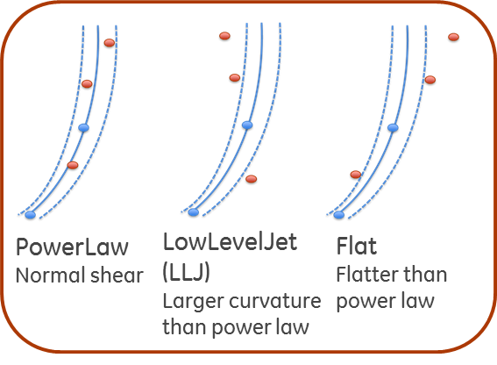

Altitude

Wind Speed

Figure: wind speed profile. (Left) fit well with power law; (Middle) Low-Level-Jet (LLJ), more curvature, smaller wind speed at the top; (Right): Flat, larger wind speed at the top. Blue dots are wind speeds at lower blade tip height and at hub. Red dots are speeds at other heights that are not available for most installed wind turbines. Blue lines are obtained using two blues dots and power.

To obtain the ground truth of the wind speed profile, GE Wind built an expensive met mast and installed 5 wind speed sensors at altitudes of 38 m, 58 m, 78.7 m, 103 m, and 122 m. Load sensors are installed in the hub at the altitude of 78.7 meters. Using a speed sensor, field engineers discovered that about 80% of the wind speed profile follows a power law:

$$V\left(h\right)=V\left(HH\right)*{\left(\frac{h}{HH}\right)}^{α}$$

where $V\left(h\right)$ is the speed at altitude $h$, $V\left(HH\right)$ is the speed at altitude $HH$, $HH$ is hub height. $α$ is the power (i.e. wind shear). For many turbines, wind speed sensors are equipped at hub height (78.7 m) and lower tip height (38 m). Therefore, it is customary in the industry to use these two speeds to calculate α.

# Your Engineering Analytic Project Deliverables

Your field team has provided a data set collected from one wind turbine that gives both wind speed from a 5 sensor met mast and load parameters from the load sensors. Field engineers have already done extensive work and labeled the wind speed profile (0: power law; 1: LLJ; 2: Flat; 3: Others).

**You are requested to produce a report that includes the analyses requested below and provides a recommendation on whether or not GE Wind should launch an NPI program to offer a “Virtual Wind Shear Sensor.”**

## Part A: Develop an algorithm to classify wind speed profile

Your first task is to develop and evaluate a classifier to see how well a speed profile can be determined from the load sensor data. Specifically, you are asked to use the load sensor data **X** from turbine sensors (14 parameters in the Appendix) to classify the wind speed profiles: 0, 1, 2, 3 (your **Y** estimator output). Be sure to include estimates of how well your classifier performs.

## Part B: Estimation of $α$ from load sensor data

If the speed profile follows a power law (ShearTypeClass 0), the shear ( $α$) can be calculated by using wind speeds at altitudes of 38 m and 78.7 m (see Appendix B for the equation). Create a predictive model for $α$ from the load sensor data and determine how well it estimates the actual $α$. In this case, you are using the same **X** load sensor inputs to infer a new continuous variable **Y**.

## Part C: Estimation of Shear when speed profile does not follow a power law (optional – worth up to 5 bonus points)

For speed profiles labeled as 1, 2, and 3, how might you create a model to estimate these profiles?

**You have about 8000 rows of data. Consider using some data for training and other data for test and validation.**

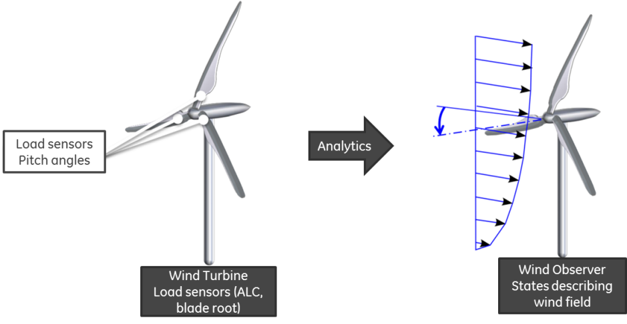

Appendix A: Parameters in the attached data set

Description of wind speed sensor parameters

m38 wind speed at height of 38 m, m/sec

m58 wind speed at height of 58 m, m/sec

m78 wind speed at height of 78 m, m/sec

m103 wind speed at height of 103 m, m/sec

m122 wind speed at height of 122 m, m/sec

Description of the turbine load sensor parameters – X variables.

RPM_0P 0P component of RPM in 1/min

nodd_0P 0P component of nodding moment in Nm

nodd_3C 3P (cosine) component of nodding moment in Nm

nodd_3S 3P (sine) component of nodding moment in Nm

pitch_d_0P 0P component of d-component of pitch angle

pitch_q_0P 0P component of q-component of pitch angle

pitch_d_3C 3P (cosine) component of d-component of pitch angle

pitch_d_3S 3P (sine) component of d-component of pitch angle

yaw_0P 0P component of yawing moment in Nm

yaw_3C 3P (cosine) component of yawing moment in Nm

yaw_3S 3P (sine) component of yawing moment in Nm

P_el 0P component of electrical power in kW

V_estim 0P component of MBC estimated wind speed in m/s

pitch_col_0P 0P component of collective pitch angle

ShearTypeClass

0: wind speed profile follows a power law;

1: LLJ

2: Flat

3: Others

Appendix B: Calculation of $α$ using tip wind speed at 38 m and hub wind speed at 78.7 m

$$V_{38m}=V_{78.7m}{\left(\frac{38}{78.7}\right)}^{α}$$

$$α=\frac{ ln\left(\frac{V_{38m}}{V_{78.7m}}\right)}{ ln\left(\frac{38}{78.7}\right)}$$